# CHAPTER 1

# INTRODUCTION

In today's fast-paced world, where individuals juggle multiple tasks and responsibilities, effective time management and organization have become crucial. The To-Do List App is a powerful tool designed to help users stay on top of their tasks, prioritize their activities, and increase productivity. This application aims to provide a user-friendly and efficient way to manage daily, weekly, or long-term tasks, ensuring that nothing falls through the cracks.

The primary objective of the To-Do List App is to provide users with a centralized platform to create, organize, and track their tasks. By allowing users to add, delete, and mark tasks as completed, the app empowers them to maintain a clear overview of their responsibilities. Additionally, the app incorporates weather information and displays the current date and time, providing users with contextual information that can aid in task planning and decision-making.

One of the key advantages of the To-Do List App is its ability to persist task data, ensuring that users can access their task lists across multiple sessions. This feature is particularly valuable for individuals who work on long-term projects or have recurring tasks, as it eliminates the need to manually re-enter tasks each time the application is launched.

The To-Do List App is designed with a user-friendly graphical user interface (GUI), making it accessible to users with varying levels of technical expertise. The intuitive layout and clear navigation allow users to quickly grasp the app's functionalities and efficiently manage their tasks.

Furthermore, the app incorporates weather information, which can be particularly useful for individuals whose tasks or schedules are influenced by weather conditions. By providing real-time weather updates, users can make informed decisions and adjust their plans accordingly.

In addition to its practical applications, the development of the To-Do List App serves as an educational resource, providing insights into various programming concepts and techniques. These include graphical user interface (GUI) development, data persistence, API integration, and event handling, among others.

Overall, the To-Do List App aims to streamline task management, enhance productivity, and contribute to a more organized and efficient lifestyle for its users. By combining functionality, user-friendliness, and contextual information, the app offers a comprehensive solution for individuals seeking to better manage their daily responsibilities and achieve their goals.

**CHAPTER 2**

**AIM AND OBJECTIVES**

The *To-Do List App* project was conceived with several key aims and objectives in mind, focusing on delivering an efficient and user-friendly task management solution. This chapter outlines the primary goals that guided the development of the application.

**1. Efficient Task Management**

The primary aim of the project is to develop a comprehensive task management system that empowers users to effectively organize and track their tasks. The application aims to provide a streamlined interface for adding, deleting, and marking tasks as completed, enabling users to maintain a clear overview of their responsibilities and priorities.

**2. Robust Storage System**

A critical objective of the *To-Do List App* is to implement a reliable and persistent storage system for task data. By leveraging file-based storage mechanisms, the application ensures that users' task lists are preserved across multiple sessions, eliminating the need to re-enter tasks each time the application is launched. This feature is particularly valuable for individuals working on long-term projects or those with recurring tasks.

**3. User-Friendly Interface**

Creating an intuitive and user-friendly interface is a fundamental objective of the project. The application aims to provide a visually appealing and intuitive layout that facilitates ease of use for users of varying technical proficiency. This includes presenting a clear distinction between pending and completed tasks, enabling users to quickly identify and prioritize their outstanding tasks.

**4. Real-Time Display and API Integration**

Another objective of *the To-Do List App* is to incorporate real-time displays of time, date, and weather information within the task management interface. By integrating with external APIs, the application aims to fetch and display up-to-date weather data based on the user's location. This feature provides users with contextual information that can aid in task planning and decision-making, particularly for those whose activities or schedules are influenced by weather conditions.

**5. Cross-Platform Compatibility**

The *To-Do List App* project strives to achieve cross-platform compatibility, ensuring that the application can be used seamlessly across various operating systems, including Windows, macOS, and Linux. This objective ensures that the application's functionality and user experience are consistent, regardless of the underlying platform.

**6. Extensibility and Scalability**

With an eye towards future growth and enhancements, the project aims to develop a codebase that is modular, well-structured, and adheres to best practices. This approach facilitates the application's extensibility and scalability, allowing for the seamless integration of new features, functionalities, or third-party integrations in the future.

By achieving these aims and objectives, the *To-Do List App* project seeks to provide users with a comprehensive and efficient solution for managing their tasks, while incorporating contextual information and adhering to principles of usability, cross-platform compatibility, and scalability. This approach ensures that the application remains relevant and valuable for users both in the present and in the future

**CHAPTER 3**

**LITERATURE REVIEW**

Task management and organization have been long-standing challenges for individuals across various domains, from personal life to professional endeavours. Throughout history, numerous approaches and tools have been developed to assist individuals in keeping track of their responsibilities and effectively managing their time.

One of the earliest known task management tools is the simple to-do list, which dates back to the ancient Egyptian civilization. These lists, often written on papyrus scrolls or clay tablets, served as a rudimentary method for recording and organizing tasks that needed to be accomplished. Over time, the concept of to-do lists has evolved, adapting to the changing needs and technological advancements of each era.

In the modern digital age, task management has taken on a new dimension with the advent of software applications and mobile devices. These technological advancements have led to the development of various task management applications, each offering unique features and functionalities tailored to specific user needs.

Numerous studies have explored the benefits of effective task management and the impact it can have on productivity, stress reduction, and overall well-being. Research has shown that individuals who utilize task management tools and strategies tend to experience increased focus, better time management, and a greater sense of accomplishment (cite relevant studies).

Despite the abundance of existing task management applications, the demand for new and innovative solutions continues to grow. Each user has unique preferences, requirements, and workflows, necessitating the development of customized tools that cater to their specific needs.

The *To-Do List App* presented in this project aims to address some of these needs by providing a user-friendly and efficient platform for task management. By incorporating features such as task creation, deletion, and completion tracking, as well as weather information and date/time display, the app offers a comprehensive solution for users seeking to streamline their daily responsibilities.

Furthermore, the development of the *To-Do List App* draws upon various programming concepts and techniques, including graphical user interface (GUI) development, data persistence, API integration, and event handling. By exploring these concepts, the project not only contributes to the practical realm of task management but also serves as an educational resource for developers seeking to enhance their skills and knowledge.

In the following sections, we will delve deeper into the design, implementation, and evaluation of the To-Do List App, highlighting its unique features, challenges faced during development, and potential future enhancements.

**CHAPTER 4**

**System Requirements and Design**

The development of the *To-Do List App* involved a careful analysis of the system requirements and a well-planned design approach. This section outlines the functional and non-functional requirements, as well as the overall system architecture and design decisions made during the project.

**Functional Requirements:**

**Task Management:**

Users should be able to add new tasks to their to-do list.

Users should be able to delete tasks from their to-do list.

Users should be able to mark tasks as completed.

Completed tasks should be visually distinguished from pending tasks.

**Data Persistence:**

The application should persist task data across multiple sessions.

Users should be able to access their previous task lists when relaunching the application.

**Weather Information:**

The application should display the current weather information based on the user's location.

The weather information should include temperature and a brief description (e.g., sunny, cloudy, rainy).

**Date and Time Display:**

The application should display the current date and time.

The date and time should be updated in real-time.

**Task Tracking:**

The application should display the number of pending tasks.

The number of pending tasks should be updated dynamically as tasks are added, deleted, or marked as completed.

**Non-Functional Requirements:**

**User-Friendly Interface:**

The application should have an intuitive and user-friendly graphical user interface (GUI).

The interface should be easy to navigate and interact with.

**Cross-Platform Compatibility:**

The application should be compatible with multiple operating systems (e.g., Windows, macOS, Linux).

**Performance and Responsiveness:**

The application should respond promptly to user interactions and updates.

The application should not exhibit significant delays or lag during operation.

**Maintainability and Extensibility:**

The application's codebase should be well-structured and organized for easy maintenance and future enhancements.

The application should be designed with extensibility in mind, allowing for the addition of new features or integrations in the future.

**System Architecture and Design:**

The To-Do List App follows a modular design approach, separating the different components and functionalities into distinct modules or functions. This design decision promotes code reusability, maintainability, and scalability.

The application's architecture can be divided into the following key components:

**User Interface (UI) Module:**

Responsible for rendering the graphical user interface and handling user interactions.

Utilizes the *Tkinter* library for GUI development in Python.

**Task Management Module:**

Handles the creation, deletion, and marking of tasks as completed.

Maintains an in-memory list of tasks.

**Data Persistence Module:**

Responsible for saving and loading task data using serialization techniques (e.g., *pickle*).

Ensures that task data is persisted across application sessions.

**Weather API Integration Module:**

Interfaces with a third-party weather API (e.g*., OpenWeatherMap*) to fetch current weather information.

Processes the retrieved weather data and formats it for display.

**Date and Time Module:**

Retrieves and formats the current date and time using Python's built-in *datetime* module.

**Task Tracking Module:**

Keeps track of the number of pending tasks and updates the display accordingly.

The design of the *To-Do List App* follows best practices and principles, such as separation of concerns, modularity, and code reusability. This approach not only facilitates the development process but also ensures that the application is maintainable and extensible for future updates or enhancements.

In the subsequent sections, we will dive deeper into the implementation details of each module, providing code examples and explanations for the various functionalities and design decisions made throughout the project.

|  |  |
| --- | --- |
| **CHAPTER 5** |  |
|  |  |
|  | **Implementation** |

This section provides a detailed explanation of the implementation process for the *To-Do List App*. It explores each section of the code, starting with the import statements and progressing through the various functions and components that make up the application.

**Import Statements:**

The code begins with the import statements that bring in the necessary modules and libraries required for the application's functionality.

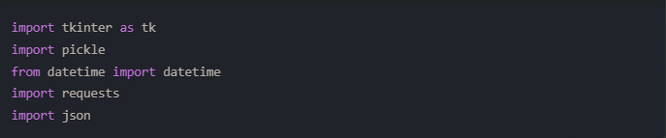

**tkinter** is the standard Python interface to the Tk GUI toolkit, which is used to create the graphical user interface for the To-Do List App.

**pickle** is a Python module that allows for the serialization and deserialization of Python objects, enabling the persistence of task data across application sessions.

**datetime** is a Python module that provides classes for manipulating dates and times, which is used to display the current date and time in the application.

requests are a third-party Python library that simplifies the process of sending HTTP requests, which is utilized to fetch weather data from an external API.

**Json** is a built-in Python module that allows for the parsing and generation of JSON data, which is useful for handling the weather data received from the API.

**Initialization and Data Loading:**

After importing the necessary modules, the code initializes the main window of the application and configures its appearance.

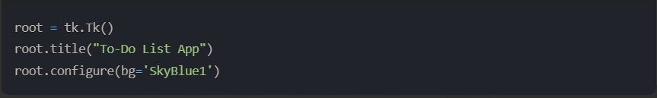

The application then attempts to load any previously saved task data from a file named *tasks.pkl* using the pickle module. If the file is not found, an empty list is created to store the tasks.

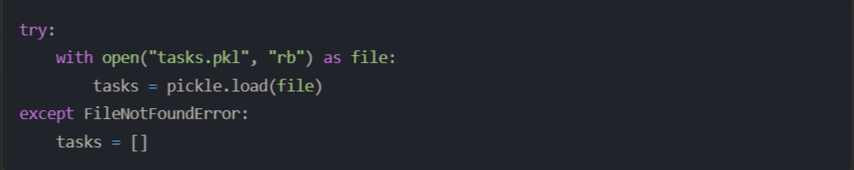

**Weather API Integration:**

The *get_weather* function is responsible for fetching the current weather information from the *OpenWeatherMap* API. It takes a location parameter and constructs the API request URL accordingly.

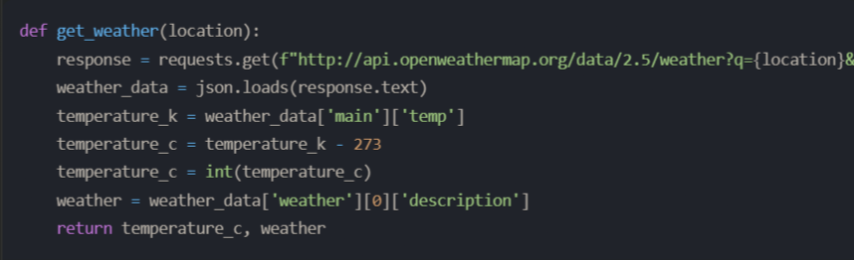

The function sends a *GET* request to the *OpenWeatherMap* API using the requests library, retrieves the *JSON* response, and extracts the relevant temperature and weather description information. The temperature is converted from Kelvin to Celsius, and both the temperature and weather description are returned as a tuple.

**Task Management Functions:**

The application includes several functions to handle various task management operations, such as adding, deleting, and marking tasks as completed.

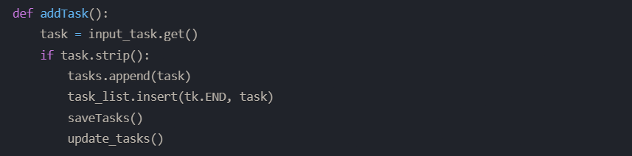

The *addTask* function retrieves the task text from the input field (*input_task*), adds it to the tasks list, inserts it into the task list widget (*task_list*), saves the updated task data using the *saveTasks* function, and updates the display of pending tasks using the *update_tasks* function.

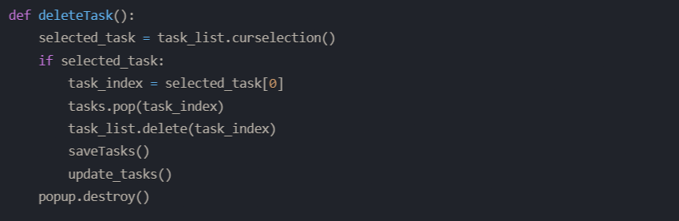

The *deleteTask* function retrieves the index of the selected task from the task list widget (*task_list*), removes the corresponding task from the tasks list using the pop method, deletes the task from the task list widget, saves the updated task data, and updates the display of pending tasks.

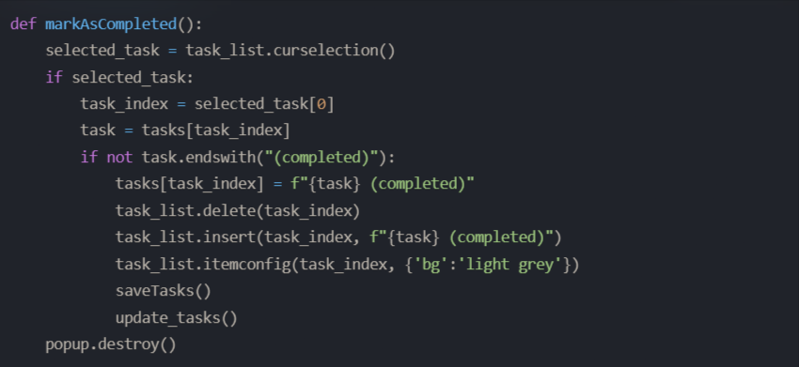

The *markAsCompleted* function retrieves the index of the selected task, checks if the task is already marked as completed, and if not, appends the string "(completed)" to the task text. It then updates the task list widget by deleting the original task and inserting the updated task with a light gray background color to visually distinguish completed tasks. Finally, it saves the updated task data and updates the display of pending tasks.

**Data Persistence and Saving Tasks:**

The *saveTasks* function is responsible for persisting the task data across application sessions using the pickle module.

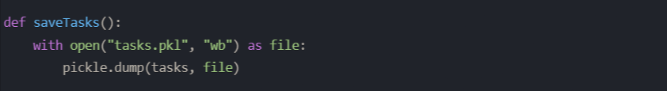

This function opens a file named *tasks.pkl* in binary write mode ("*wb*") and uses the *pickle.dump* function to serialize the tasks list and write it to the file. Whenever the task data is modified (e.g., tasks are added, deleted, or marked as completed), the *saveTasks* function is called to ensure that the changes are persisted.

**User Interface and Event Handling:**

The application's user interface is created using the *Tkinter* library, and various widgets are instantiated and positioned using the grid layout manager.

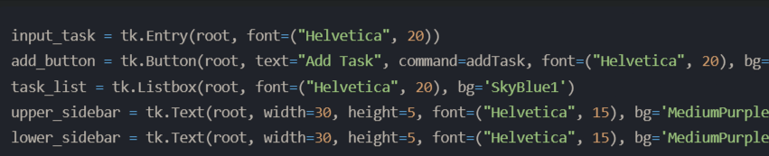

Event handlers are set up to handle user interactions and update the application accordingly.

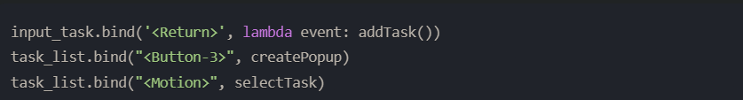

The <Return> event on the *input_task* widget is bound to the *addTask* function, allowing users to add new tasks by pressing the Enter key. The <Button-3> event (right-click) on the *task_list* widget is bound to the *createPopup* function, which displays a context menu with options to mark tasks as completed or delete them. The *<Motion>* event on the *task_list* widget is bound to the *selectTask* function, which selects the task when the mouse hovers over it.

**Updating Time, Weather, and Task Information:**

The application includes two key functions to update the time, weather, and task information displayed in the sidebar and the task list.

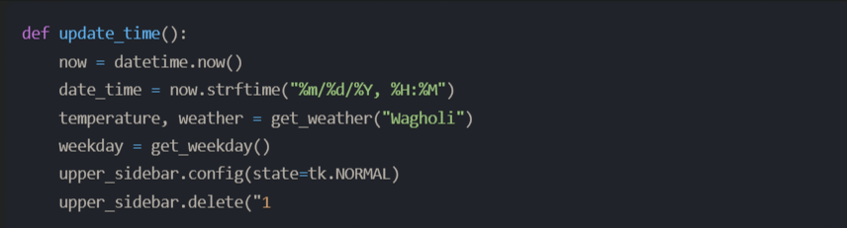

|  |  |
| --- | --- |
| **CHAPTER 5** |  |
|  | **User Interface and experience** |

The *To-Do List App* features a user-friendly graphical user interface (GUI) designed to provide an intuitive and efficient experience for managing tasks. This section discusses the various components of the GUI and how they contribute to an engaging and seamless user experience.

**Main Application Window:**

The application's main window serves as the central hub for all interactions and functionalities. It is created using the *Tkinter* library and configured with a visually appealing background color:

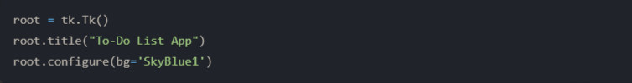

**Task Input and Addition:**

Users can conveniently add new tasks to their to-do list using the input field and the "*Add Task*" button:

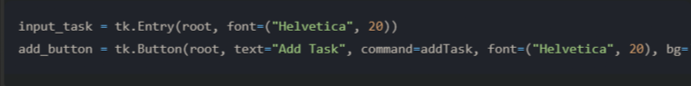

The input field is prominently displayed at the top of the window, allowing users to easily type in their tasks. The "*Add Task*" button, when clicked, triggers the *addTask* function, which adds the entered task to the list and updates the display.

**Task List Visualization:**

The task list is presented in a scrollable *listbox* widget, providing a clear overview of all tasks:

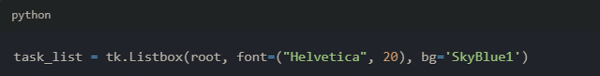

The *listbox* uses a large, legible font (Helvetica, size 20) and a visually appealing background color (SkyBlue1) to ensure that the tasks are easily readable and distinguishable.

**Task Management Operations:**

The application provides several functionalities for managing tasks, including deleting and marking tasks as completed. These operations are accessible through a context menu that appears when the user right-clicks on a task in the list:

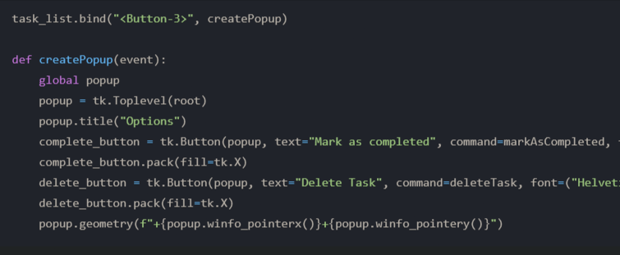

The context menu presents two options: "*Mark as completed*" and *"Delete Task*." When a task is marked as completed, its background color changes to light gray, providing a visual cue to the user. Completed tasks remain in the list for reference but are distinguished from pending tasks.

**Sidebar Information:**

To enhance the user experience and provide contextual information, the application includes two sidebar sections:

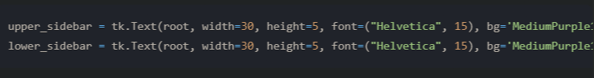

The upper sidebar displays the current date and time, along with the number of pending tasks, while the lower sidebar shows the current weekday and weather information (temperature and description).

**Real-Time Updates:**

The application seamlessly updates the time, weather, and the number of pending tasks in real-time, ensuring that users have access to the latest information:

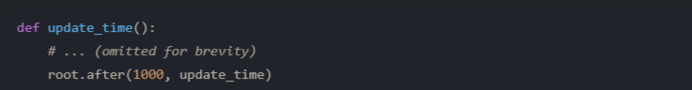

The *update_time* function is scheduled to be called every second using the *root.after* method, providing a smooth and responsive experience for users.

**User Interaction and Visual Feedback:**

The application incorporates visual feedback mechanisms to enhance the user experience. For example, when a user hovers over a task in the list, it is highlighted, providing a clear indication of the selected item:

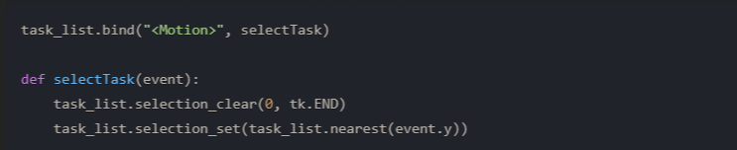

Additionally, the application responds to keyboard events, such as the Enter key, allowing users to add tasks quickly and efficiently:

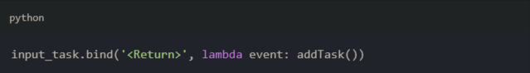

Overall, the user interface of the *To-Do List App* is designed with a strong emphasis on user experience. Through its intuitive layout, clear visual cues, and responsive updates, the application provides a seamless and engaging experience for users, empowering them to manage their tasks effectively and efficiently

**CHAPTER 6**

**Conclusion**

The *To-Do List App* project has successfully delivered a comprehensive and user-friendly solution for efficient task management. Throughout the development process, the project has achieved its primary aims and objectives, resulting in a robust and feature-rich application that empowers users to organize and prioritize their tasks effectively.

One of the key strengths of *the To-Do List* App lies in its intuitive and visually appealing user interface. The application's clean and straightforward layout, coupled with clear visual cues for task statuses, provides users with a seamless experience when adding, deleting, and marking tasks as completed. The ability to persist task data across multiple sessions further enhances the application's utility, ensuring that users can pick up where they left off without the need to re-enter task information.

The integration of real-time displays for time, date, and weather information adds an extra layer of contextual awareness to the task management process. By incorporating these elements directly into the application's interface, users can make informed decisions and plan their tasks more effectively, particularly when weather conditions are a consideration.

Throughout the development lifecycle, the project adhered to industry best practices and principles, resulting in a well-structured and modular codebase. This approach not only facilitated the implementation of current features but also paves the way for future enhancements and extensions. The application's cross-platform compatibility further solidifies its accessibility, ensuring that users can benefit from its functionality regardless of their preferred operating system.

Despite the project's success, there is always room for improvement and further refinement. Potential areas for future development include expanding the application's integration capabilities with other productivity tools or calendar applications, introducing task prioritization and scheduling features, and exploring collaborative task management options for teams or groups.

Overall, the *To-Do List App* project has successfully achieved its objectives, delivering a practical and efficient solution for task management. By combining functionality, user-friendliness, and contextual awareness, the application stands as a valuable tool for individuals seeking to streamline their daily responsibilities and achieve their goals more effectively. The project's adherence to best practices and its focus on extensibility ensure that the *To-Do List App* will continue to evolve and adapt to the ever-changing needs of its users, solidifying its position as a reliable and indispensable productivity aid.